- Motivation of your dashboard
This dashboard is designed to communicate the relationship between prenatal exposure to glyphosate and AMPA and biomarkers of oxidative stress in a prospective birth cohort. It seeks to translate these results into an interactive visual format, making patterns in exposure–biomarker associations more interpretable and accessible. Specifically, the dashboard aims to visually compare associations between glyphosate and AMPA across multiple oxidative stress biomarkers, highlight exposure contrasts (IQR and tertiles) in a standardized way, and show the strength and direction of linear relationships using Pearson correlation coefficients. By presenting regression estimates and correlation structure, the dashboard allows users to evaluate consistency, magnitude, and direction of associations in a cohesive format.

- Your dataset and data source
I had 3 datasets provided by mentor which I merged, cleaned, and conducted analyses on.
Copied and pasted from the methods section of my manuscript:
Study population
The present analysis includes a subset of individuals enrolled in the Illinois Kids Development Study (IKIDS), an ongoing, prospective birth cohort that is part of the Environmental influences on Child Health Outcomes (ECHO) Program. IKIDS was originally designed to investigate the impact of prenatal environmental exposures on offspring neurodevelopment. Details of the study design and recruitment process have been described extensively elsewhere.²⁷ Briefly, pregnant women were recruited from two obstetric clinics in Champaign-Urbana, IL. Pregnant women were eligible for enrollment if they were 18-40 years old, fluent in English, carrying a low-risk singleton pregnancy, and between 10 and 15 weeks pregnant. Following enrollment, validated questionnaires and medical record abstraction were used to collect information regarding demographic and lifestyle information, including maternal age, pre-pregnancy weight, height, race/ethnicity, marital status, parity, education, diet, and employment status. Participants also provided urine samples at multiple timepoints during pregnancy. All individuals provided written informed consent, and the study was approved by the Institutional Review Board at the University of Illinois Urbana-Champaign. A subset of IKIDS participants with available urinary glyphosate and AMPA metabolite and oxidative stress biomarker information was included in this analysis (N=161).
- The target audience and at least 2 questions they may be interested in
The target audience includes public health researchers, environmental epidemiologists, maternal and child health researchers, and policy stakeholders interested in herbicide exposure.
Q1: Are higher prenatal glyphosate or AMPA concentrations associated with increased oxidative stress biomarkers?
Q2: Do glyphosate and AMPA show similar patterns of association across biomarkers?
Q3: How strong are the linear relationships between exposures and oxidative stress biomarkers?
- Draw at least two interactive visualizations (with axes, labels, title, general mock up of visualization) that answer the questions you listed in #3.
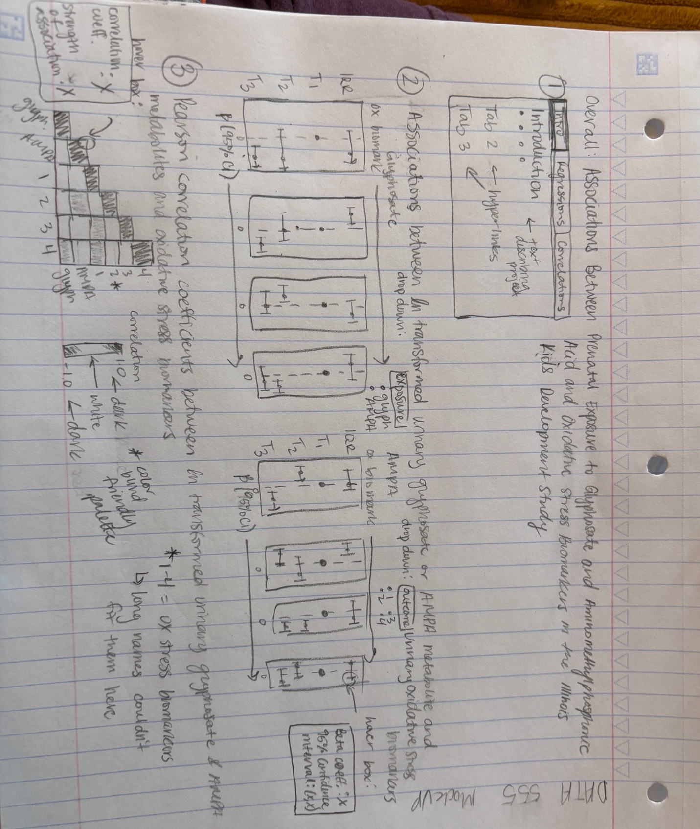
- Describe what components of the plot will be interactive (i.e., hover annotation boxes, interactive data table, alphabetical lookup (click on a name and information or a graph pops up), zoom in/zoom out, other plotly, html widgets or dt() interactive tools etc).
The dashboard will consist of three interactive tabs designed to guide users from background context to detailed analytical results. The first tab will provide an introduction to the study, including brief information on the cohort, exposure assessment, oxidative stress biomarkers, and the overall analytic framework. This section will orient users to the scientific context and clarify how to interpret the visualizations presented in the subsequent tabs.
The second tab will display forest plots of regression results, with glyphosate and AMPA shown side by side to facilitate direct comparison. Each exposure will include four panels corresponding to different model specifications or exposure metrics. Users will be able to interact with the plots using dropdown filter boxes that allow them to select a specific exposure, a specific oxidative stress biomarker outcome, or both simultaneously. The plots will dynamically update based on the selected filters, enabling focused comparisons while maintaining the overall structure of the visualization. Each point estimate will include a hover annotation box that displays the exact beta coefficient and 95% confidence interval, allowing users to view precise numerical results without cluttering the figure.
The third tab will present a Pearson correlation coefficient heatmap illustrating the relationships between exposures and oxidative stress biomarkers. The default view will display only color gradients to represent the direction and magnitude of correlations, reducing visual complexity. Users will be able to hover over individual cells to reveal the exact correlation coefficient and a qualitative interpretation of the strength of the association (e.g., weak, moderate, or strong).

